**User Guide – “Gathering of Gamers”**

**Application installation instructions**

Our application is intended for Android devices only.

A mobile device with an Android operating system version 11.0 or higher.

Checking the Android version installed on your device: On your device, go to "Settings" > "About phone" > "Software details" > "Android version".

Let’s start:

1. Make sure that you have google drive installed on your device.
2. Open this link with your device:

<https://drive.google.com/drive/folders/1BZNIapud8voWFZJIjMmK5wnnQzUgUDZy?usp=share_link>

1. Click "Download". The file download will start immediately. If an error message appears saying that your device is blocked from installing apps from this source, click on "Settings" in the panel that opens and enable the "Google Drive" source.
2. When the download is over you’ll see this Icon on your Phone  , Click on it.

**Login page:**

* Existing user - enter username and password and click Login.
* New user – Click on “Don’t have an account yet? SignUp.

**Sign Up page:**

* Fill all the required fields:
  + Username.
  + Password.
  + Confirm password.
  + Gender.
  + Choose location.
  + Date of Birth.
* Click on Sign Up.
* After that a new button will appear that called Next.
* Click on Next.

**Add Game Page:**

* Select game by scrolling down and choose a game from the list
* Fill the 3 Factors for that specific game:
  + Competitive level [1-5]
  + Skill level [1-5]
  + Communication level [1-5]
* Click on Save.
* Go to profile button will show up, Click on it.

**Profile Page (Fragment)**

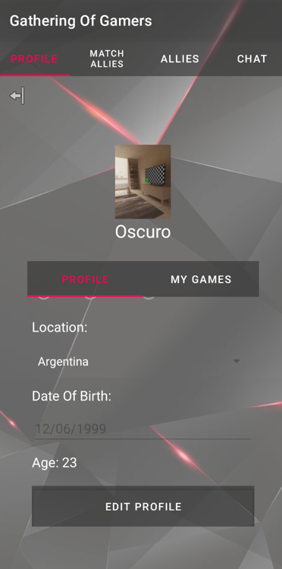

* This is the Profile Page, where you can slide and go to My Games where you can see all your games and add new games that you are currently playing. You can also Edit your profile details, by clicking on the edit button, all the elements on your screen will be editable and you can save it after that.
* You can upload profile picture from your gallery and by taking picture from your device camera.

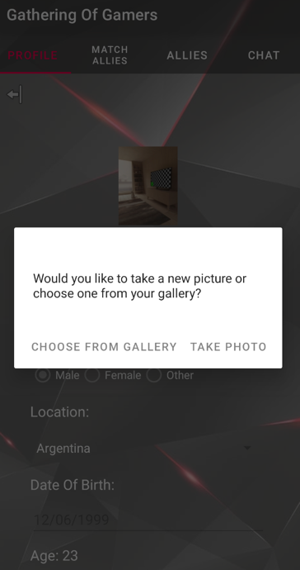

* **The My games fragment:**

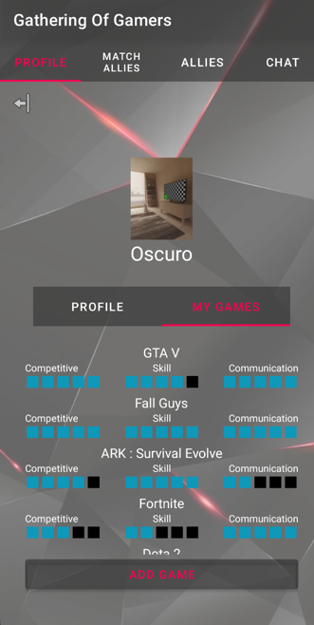

* + When you click on Add Game, You will get back to the adding game page and you add new games.
* **Match Allies fragment:**

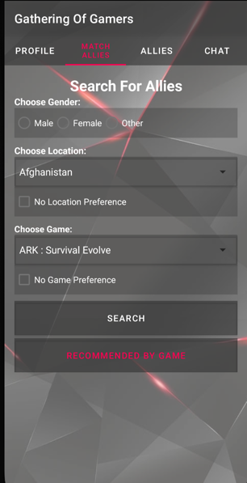

* This is the heart of our application; you can start searching for allies in this page by doing the following:
  + You can search by Gender.
  + Choose location, You can choose no location preference.
  + Search by game, and like the location, you can search with no game preference.
* We also have Recommendation System, That you have to choose game that you are currently playing and the system will recommend Players for you to add with a percentage match.

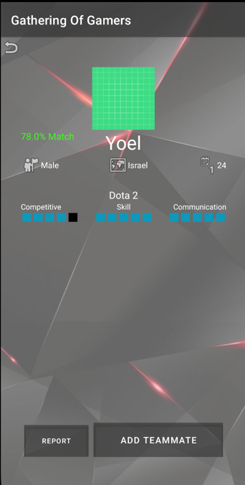

* After the players show on your screen, you can add the players, by sending them a friend request.
* **The Allies fragment:**
  + You can check received friend request your sent requests, and your current allies.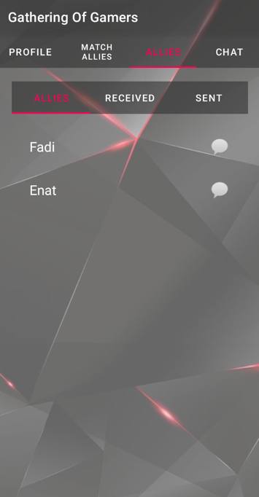
  + You can start chatting with your allies by clicking on the chat icon, the chat page will open.
* **Chat Page:**
  + You can start chatting with your allies in this chat page just like any chat.

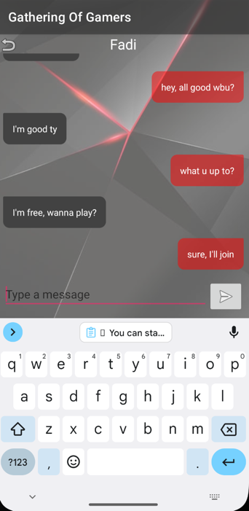

* **The Chat fragment:**
  + You can see all your chats that you did with your allies in this page.

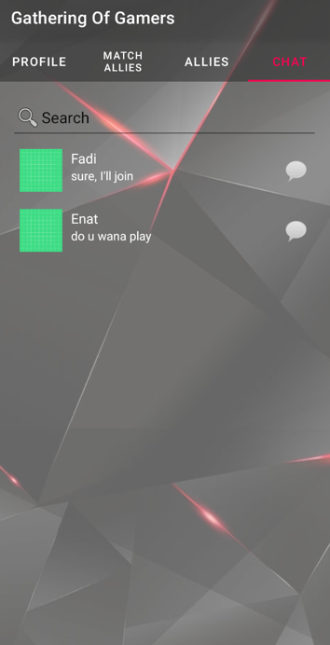

**For signing out you can click on the icon that you have on the top left corner on the profile fragment.**